|  |
| --- |
|  |
| Car-web-services Report |
| Internet and Multimedia System |
|  |
| **Yujie He** |
| **4/16/2015** |

|  |
| --- |
| This is an informal document that briefly explains what the author did for the assignment of Internet and Multimedia System. |

# Prerequisites

## MySQL

You must install [MySQL](https://dev.mysql.com/downloads/installer/) and have root permission. Run ‘MySQL command line client’. Create a database called ‘car’ for car-web-services project to use. You also need to create a test user to let web service application access database. All can be done by following code

1. mysql> CREATE DATABASE car;
2. mysql> CREATE USER ‘test’@’localhost’ IDENTIFIED BY ‘test’;
3. mysql> GRANT ALL ON car.* TO ‘test’@’localhost’;

## Maven (Optional)

You can either use a given compiled WAR file from *car-web-services\target* to deploy OR use Maven to build project.

If you want to build the project on a PC, you have to make sure that [Maven 3.2.5](http://maven.apache.org/download.cgi) is installed.

1. Follow [tutorial](http://maven.apache.org/guides/getting-started/maven-in-five-minutes.html) to install Maven
2. Go to maven repository folder (*C:\Users\****YourUsername****\.m2*)
3. Copy settings.xml from *car-web-services\src\main\resources\settings.xml* into *C:\Users\****YourUsername****\.m2*
4. Open command window and change directory to car-web-service project home (in which pom.xml exists). Run ‘**mvn clean package’**.
5. Built package is under *car-web-services\target*

## JBoss

To deploy project package, download [JBoss EAP 6.3.0.GA](http://www.jboss.org/products/eap/download/) and configure settings as follows

1. Unzip JBoss EAP package and change directory to *jboss-eap-6.3* (called JBOSS_HOME)
2. Install mysql module by copying *car-web-services\src\main\resources\mysql.7z* to *JBOSS_HOME\modules\system\layers\base*
3. Unzip mysql.7z in *JBOSS_HOME\modules\system\layers\base* directory
4. Check *JBOSS_HOME\modules\system\layers\base\com\mysql\main* folder has one jar file and one xml file. If not, you didn’t unzip correctly in step 3
5. Copy *car-web-services\src\main\resources\standalone-car.xml* to *JBOSS_HOME*\*standalone\configuration* directory.
6. Run a command window and change directory to *JBOSS_HOME\bin*. Start JBOSS EAP 6.3 by typing ***standalone.bat -c standalone-car.xml***

# C:\Users\eyujihe\Desktop\Capture.PNGShort Server Side Illustration

Server side implementation is under *car-web-services\src\main\java* package.

The implementation relies on a stateful EJB to work on business service and Hibernate framework to persist models to database. CarResource.java consists of a set of JAX-RS restful web services that expose CRUD operations to support client requests. It delegates all incoming requests to an EJB to perform business logic.

# Client Design

The client side illustration more focuses on techniques used. Image below depicts third party JavaScript libraries applied in client implementation.

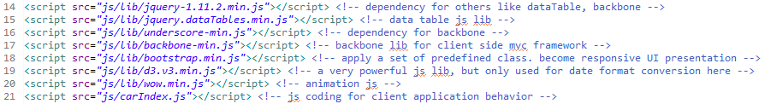

## C:\Users\eyujihe\Desktop\Capture.PNGSprint 0: basic table, header, footer, and styling

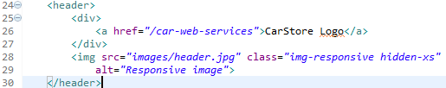At sprint 0, I didn’t put much effort on static content of basic table. It only had an empty table placeholder.

C:\Users\eyujihe\Desktop\Capture.PNG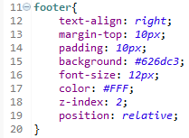Header section consists of a division for branding logo and a background image. It has a ‘hidden-xs’ class modifier to hide background image when displaying on extreme small device.

Footer section sits at the bottom of the page. It has a simple text for copyright. Some styling design shows as follows

### Bootstrap

There are a lot of place using Twitter Bootstrap styling to improve design of layout. Some of them will be discussed in late sections. Here I presents some class modifiers that are in place in application

Use .container for a responsive fixed width container.



Use “col-xs-12”, “col-sm-6”, “col-md-4” for responsive columns



## Sprint 1: Ajax, Dialog, Tabs

### Ajax

Since Ajax feature is gracefully wrapped by jQuery, no low level coding, like creating XMLHttpRequest object, can be replaced with $.ajax() function. As Backbone extends jQuery and provides API for saving, fetching, and destroying models, it abstracts service requests again to a state where no obvious service invocation presents in code. I will elaborate client-server communication in Sprint 2 – BackboneJS section.

### Dialog

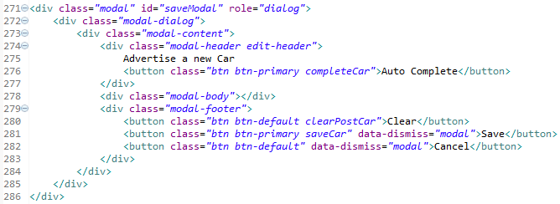

Bootstrap modal offers an easy way to create a dialog. Code snippet above is html part for create a dialog. A modal dialog typically composes of three divisions, header, body, and footer. The body div does not have anything because it is populated by JavaScript coding.

Bootstrap modal can be controlled by JavaScript. To show a dialog , $('#saveModal').modal('show'); To hide a dialog, $('#saveModal').modal('hide'); Or have an attribute data-dismiss=”modal” on a button tag.

### Tabs

Bootstrap tab is also a convenient widget to use. You don’t have to do any JavaScript coding to toggle different sections when a user clicks tab. It is all done by Bootstrap once you have correct class name applied. I design index page to have three tabs, the last of which has a further dropdown menu to select. Following code snippet shows how to design the full tab feature in great support of Bootstrap.

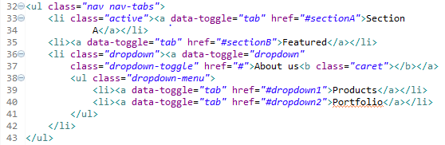

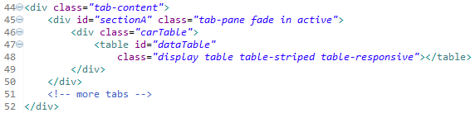

## Sprint 2: BackboneJS, CRUD, Featured Products, Pagination, Gallery

### BackboneJS + CRUD

BackboneJS supplies ground APIs to perform CRUD operations on models. Developers do not have to be aware of setting up network object to communicate with services. They can simply create a Backbone model/collection holding necessary data to be transmitted, and then invoke save() for creating and updating, fetch() for reading, and destroy() for deleting to make a service request.

|  |  |
| --- | --- |
| Service Type | Sample Code in project |
| Create  (POST) | C:\Users\eyujihe\Desktop\Capture.PNG |
| Read  (GET) | C:\Users\eyujihe\Desktop\Capture.PNG |
| Update  (PUT) | C:\Users\eyujihe\Desktop\Capture.PNG |
| Delete  (DELETE) | C:\Users\eyujihe\Desktop\Capture.PNG |

### Featured Products

Featured products section displays hottest cars and presents a nice, clean view to customers. Technical speaking, it is made up of an html list with proper styling. In client application, the list is populated based on result set that returns from service call. The following images depict html elements and JavaScript that acts on the receipt of data to show UI looking.

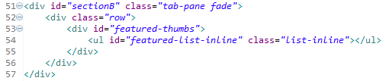

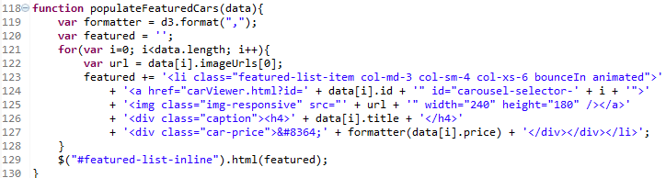

### Pagination

Pagination is a given feature by jQuery DateTable plugin. DataTables is a plug-in for the [jQuery](https://jquery.com/) Javascript library. It is a highly flexible tool, based upon the foundations of progressive enhancement, and will add advanced interaction controls to any HTML table. To use jQuery DataTable, first you need a table placeholder in html

C:\Users\eyujihe\Desktop\Capture.PNG

After that, use jQuery to locate the DOM element and design the layout of data table with configuration of your own choice. You can even post process format of data in configuration.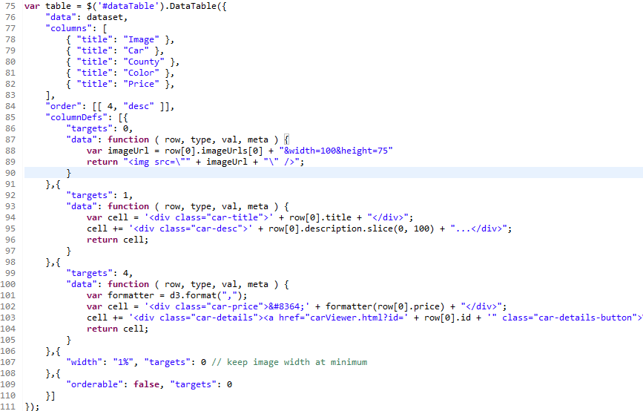

Here ‘dataset’ is an array of array. The first element of child array is model object that has all information.

The columnDefs option allows a column definition object to be defined and then assigned to one or more columns in a DataTable, regardless of the order of the column definitions array, or the order of the columns in the table. The columnDefs.targets option provides the information required by DataTables for which columns in the table the column definition object should be applied.

For example, as I stated early, first element of row data is model object which needs to be post-processed because model object could not be display properly in web UI. “targets”: 0 means that this is extra working on first row. “data”: function(row, type, val, meta){} describes how to interpret the data and display the content. Here I return an image as content of the first column in a row.

### Gallery

Carousel is a slideshow component for cycling through elements, like a carousel. To have a gallery, you need have an html section below. Thumbnail navigation part is not necessary to have in a basic Bootstrap Carousel. It is an additional work to enrich the user experience when gallery is sliding.

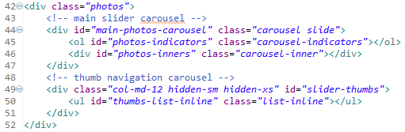

When the div with id=”photo-inners” fills with item div, we can make carousel active by running following line.

C:\Users\eyujihe\Desktop\Capture.PNG

# Screenshots:

Finally, some static screenshots are presented to give you an overall view in advance. With the aid of text explanations, the author highlights the technologies used in the car-web-services application

